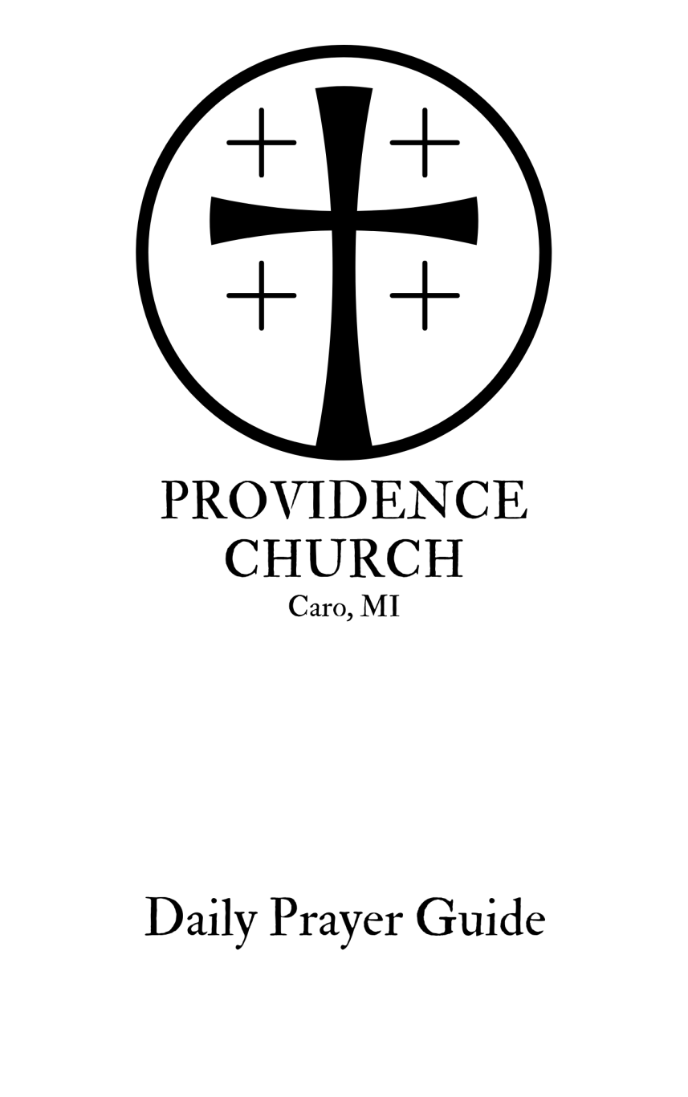

Index

Introduction: 4

Collects: 6

Morning Prayer: 8

Evening Prayer: 13

How to Use This Prayer Guide

This prayer guide is drawn loosely from the liturgies of morning and evening prayer in the Book of Common Prayer. For millennia, the people of God have structured their time around worship. In the Western Church, the Daily Office is most often observed as Morning Prayer and Evening Prayer, and that is what we have provided here.

Rubric Symbols
℣. Versicle: Indicates a line that is said or sung by the minister (or other leader, if said at home.)
℟. Responsory: Indicates a line that is said or sung by the congregation (or family, if said at home.)
If the Daily Office is being said by an individual, he or she reads both the Versicles and Responsories.

Scripture Readings and Psalms
In both rites, there is a time for Scripture reading and Psalm reading or singing. We have left how you will go about that up to you. There are daily readings that go along with our weekly Sunday lectionary readings, and they may be found online here, selecting “Daily Lectionary Readings” toward the bottom of the page: https://lectionary.library.vanderbilt.edu/
You may have a “Through the Bible in a year” reading plan, or simply chose to read more slowly through a selected book of Scripture.
A psalm may simply be read, or a metrical or chant setting sung.

Collects
A “collect” is a short form of prayer calling God to action based on His character and past work. There are resources that provide collects tracking with the Church year. We have also given a selection of collects at the beginning of this guide that may be helpful to you as well.

This is For You
This prayer guide is intended to be helpful for you as you seek God in prayer and devotion throughout your week, whether individually or together as a family. Our hope is to make the rich liturgical life of the Daily Office accessible to all.
It’s for you; that is, it is not intended to be a burden. I hope that you find it helpful. If you find that it works better for you to shorten what is given here, or make other changes, please feel free to do so. If you have your own practices of prayer and Scripture reading that you prefer, of course that’s fine. Our hope is that this may enrich your life of prayer as a disciple of Christ.

I pray God’s rich blessings on you all as you grow in the grace and knowledge of our Lord Jesus Christ, by the help of the Spirit.
If you have any questions, please feel free to get in touch.

The peace of Christ be with you,
Pr. Jacob Hanby
(989) 912-9260
jg.hanby5@gmail.com

Collects

A Collect for Sundays
O God, Who makes us glad with the weekly remembrance of the glorious Resurrection of Your Son our Lord: Grant us this day such blessing through our worship of You, that the days to come may be spent in Your favor; through Jesus Christ our Lord. Amen.

A Collect for Fridays
Almighty God, Whose dear Son went not up to joy but first He suffered pain, and entered not into glory before He was crucified: Mercifully grant that we, walking in the way of the Cross, may find it none other than the way of life and peace; through Jesus Christ Your Son our Lord. Amen.

A Collect for Renewal of Life
O God, the King eternal, Whose light divides the day from the night and turns the shadow of death into the morning: Drive far from us all wrong desires, incline our hearts to keep Your instruction, and guide our feet into the way of peace; that, having done Your will with cheerfulness during the day, we may, when night comes, rejoice to give You thanks; through Jesus Christ our Lord. Amen.

A Collect for Peace
O God, the Author of peace and Lover of concord, to know You is eternal life and to serve You is perfect freedom: Defend us, Your humble servants, in all assaults of our enemies; that we, surely trusting in Your defense, may not fear the power of any adversaries; through the might of Jesus Christ our Lord. Amen.

A Collect for Guidance
Heavenly Father, in You we live and move and have our being: We humbly pray You so to guide and govern us by Your Holy Spirit, that in all the cares and occupations of our life we may not forget You, but may remember that we are ever walking in Your sight; through Jesus Christ our Lord. Amen.
A Collect for Times of Affliction
Lord, Who knows the deep places through which our lives must go: Help us, when we enter them, to lift our hearts to You, to be patient when we are afflicted, to be humble when we are in distress; and grant that the hope of Your mercy may never fail us, and the consciousness of Your lovingkindness may never be clouded nor hidden from our eyes; through Jesus Christ, Your Son, our Lord. Amen.

A Collect for Evening
Watch, dear Lord, with those who wake, or watch, or weep tonight, and give Your angels charge over those who sleep. Tend Your sick ones, O Lord. Rest Your weary ones. Bless Your dying ones. Soothe Your suffering ones. Pity Your afflicted ones. Shield Your joyous ones. And grant grace unto all, for Your love’s sake, in Jesus Christ our Lord. Amen.

A Collect for Those in Affliction
Almighty and everlasting God, the comfort of the sad, the strength of them that suffer: Let the prayers of Your children who cry out of any tribulation come unto You; and unto every soul that is distressed grant mercy, grant relief, and grant refreshment; through Jesus Christ, our Lord. Amen.

A Collect for The Church
Most gracious Father, we humbly beseech You for Your holy catholic Church. Fill it with all truth, in all peace. Where it is corrupt, purify it; where it is in error, direct it; where anything is amiss, reform it; where it is right, strengthen and confirm it; where it is in want, provide for it; where it is divided and rent asunder, heal the breaches thereof, O Holy One of Israel; through Jesus Christ our Lord. Amen.

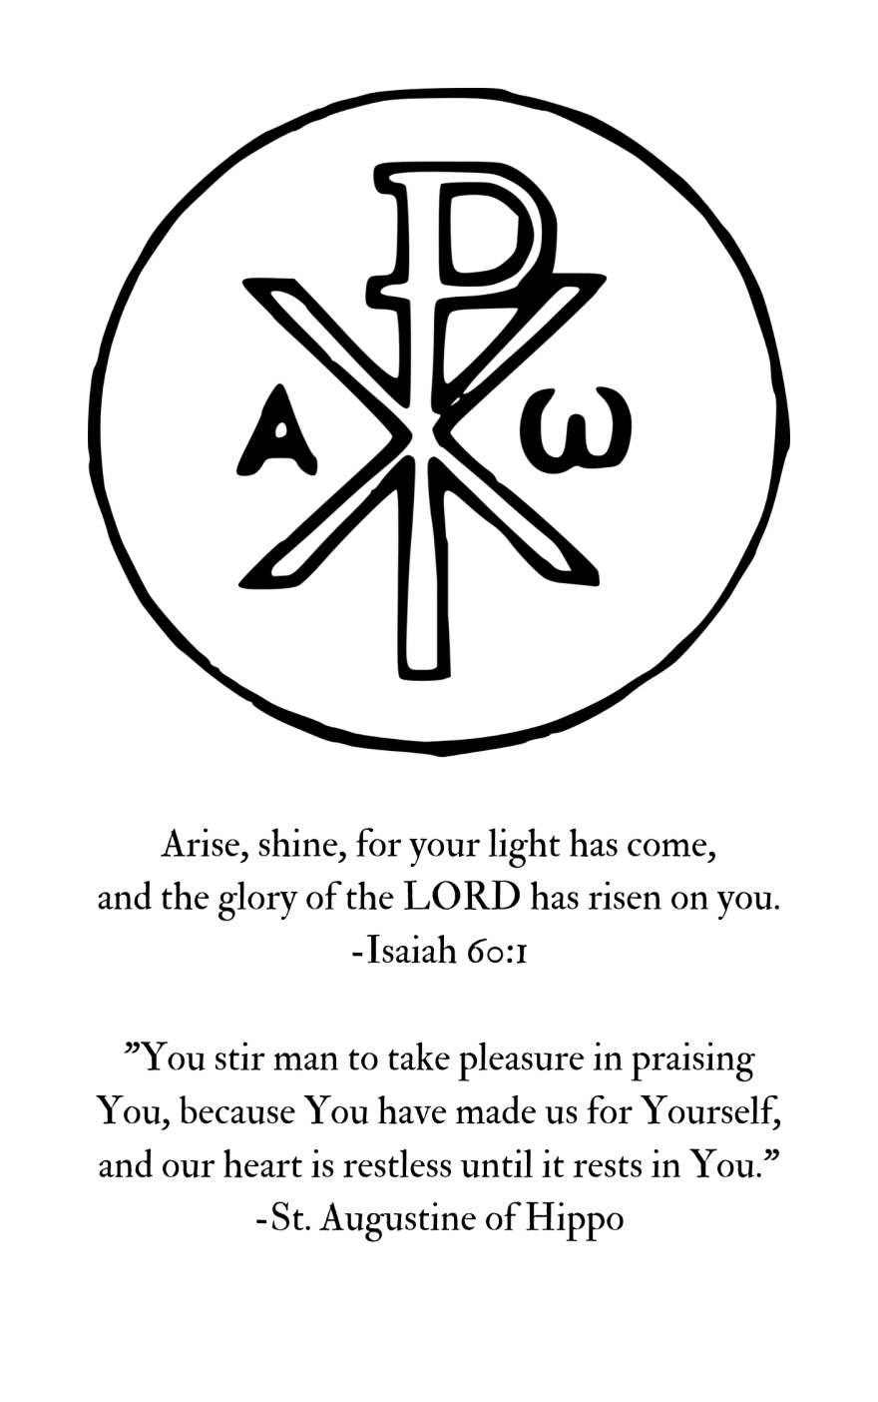
Morning Prayer

℣. O Lord, open my lips.
℟. And my mouth shall show forth thy praise.

℣.Glory to † the Father, and to the Son, and to the Holy Spirit:
℟. As it was in the beginning, is now, and ever shall be, age after age. Amen.

Confession of Sin
℣. Let us humbly confess our sins unto Almighty God.

A time of silent confession may be observed

℟. O God, our heavenly Father, I confess to You that I have grievously sinned against You in thought, word, and deed; not only in outward transgressions, but also in secret thoughts and desires that I am unable fully to understand, but which are all known to You. I am in need of deliverance from Your enemies and my infirmities. For this reason I flee for refuge to Your infinite mercy, seeking and imploring Your forgiveness and deliverance, through my Lord Jesus Christ. Amen.

℣. The Almighty and merciful Lord grant us absolution and remission of all our sins, true repentance, amendment of life, and the grace and consolation of the Holy Spirit. Amen.

Venite (Psalm 95)
℟. Come, let us sing for joy to the LORD;
Let us shout to the Rock of our salvation;
Let us come before His face with thanksgiving;
With songs let us shout to Him.
For a great Mighty One is the LORD,
And a great King above all Gods.

In His hand are the depths of the earth,
And the peaks of the mountains are His.
His is the sea, for He made it,
And the dry land His hands formed.

Come, let us worship and bow down;
Let us kneel before the LORD our Maker.
For it is He Who is our God,
And we are the people of His pasture,
And the sheep of His hand.

The Hymn and/or Psalm
(One or more Psalms may be sung or said.)

The Scripture Lesson
(A time of reflection or teaching may follow.)

The Apostles’ Creed
℟. I believe in God, the Father Almighty, Maker of heaven and earth;
And in Jesus Christ His only Son our Lord; Who was conceived by the Holy Spirit, born of the Virgin Mary, suffered under Pontius Pilate, was crucified, dead, and buried. He descended into hell. The third day He rose again from the dead. He ascended into heaven, and sits on the right hand of God the Father Almighty. From thence He will come to judge the living and the dead.
I believe in the Holy Spirit, the holy catholic Church, the communion of saints, the forgiveness of sins, the resurrection of the body, and the life everlasting. Amen.

The Lord’s Prayer
℟. Our Father, Who art in heaven: hallowed be Thy Name; Thy Kingdom come, Thy will be done, on earth as it is in heaven. Give us this day our daily bread, but forgive us our debts, as we forgive our debtors. Lead us not into temptation, but deliver us from evil. For Thine is the kingdom, and the power, and the glory, forever. Amen.

Here may be added intercessions and thanksgivings.

The Collect for the Day
See collects at the beginning of this booklet.

The Collect for Grace
℟. O Lord, our heavenly Father, Almighty and everlasting God, who has safely brought us to the beginning of this day: Defend us in the same with Your mighty power; and grant that this day we fall into no sin, neither run into any kind of danger; but that all our doings, being ordered by Your governance, may be righteous in Your sight; through Jesus Christ, Thy Son, our Lord, who lives and reigns with You and the Holy Spirit, one God, age after age. Amen.

Benediction
℣.The grace of our Lord Jesus Christ [†], the love of God, and the fellowship of the Holy Spirit be with us all evermore. (2 Cor. 13:14)
℟. Amen.

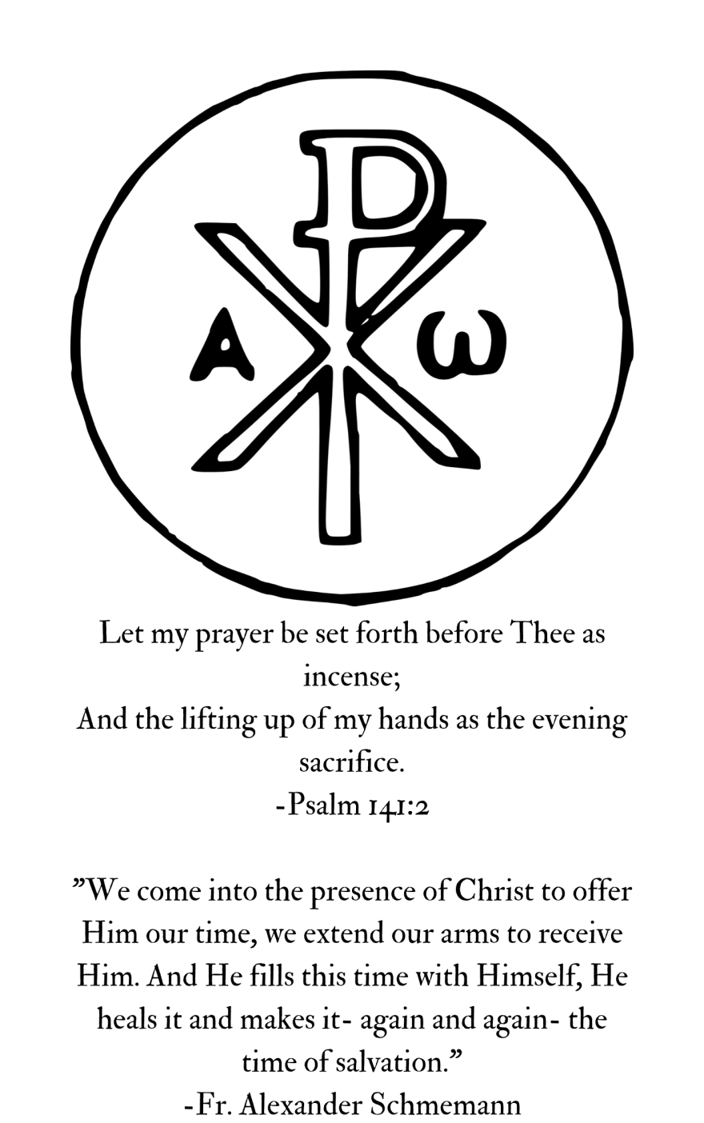
Evening Prayer

℣. O Lord, open my lips.
℟. And my mouth shall show forth thy praise.

℣.Glory to † the Father, and to the Son, and to the Holy Spirit:
℟. As it was in the beginning, is now, and ever shall be, age after age. Amen.

Confession of Sin
℣. Let us humbly confess our sins unto Almighty God.

A time of silent confession may be observed

℟. O God, our heavenly Father, I confess to You that I have grievously sinned against You in thought, word, and deed; not only in outward transgressions, but also in secret thoughts and desires that I am unable fully to understand, but which are all known to You. I am in need of deliverance from Your enemies and my infirmities. For this reason I flee for refuge to Your infinite mercy, seeking and imploring Your forgiveness and deliverance, through my Lord Jesus Christ. Amen.

℣. The Almighty and merciful Lord grant us absolution and remission of all our sins, true repentance, amendment of life, and the grace and consolation of the Holy Spirit. Amen.

Phos Hilarion (O Gladsome Light)
℟. O Gracious Light,
Pure brightness of the ever-living Father in heaven,
O Jesus Christ, holy and blessed!

Now as we come to the setting of the Sun,
And our eyes behold the vesper light,
We sing Your praises, O God: Father, Son, and Holy Spirit.

You are worthy at all times to be praised by happy voices,
O Son of God, O Giver of Life,
And to be glorified in all the worlds.

The Hymn and/or Psalm
(One or more Psalms may be sung or said.)

The Scripture Lesson
(A time of reflection or teaching may follow.)

Nunc Dimittis (The Song of Simeon)
℟. Master, let Your servant depart in peace,
According to Your word;
For my eyes have seen Your salvation,
Which You have prepared, before the face of all people,
A light of revelation to the Gentiles,
And the glory of Your people, Israel.
Glory to the Father, and to the Son, and to the Holy Spirit:
As it was in the beginning, is now, and will be forever. Amen.

The Apostles’ Creed
℟. I believe in God, the Father Almighty, Maker of heaven and earth;
And in Jesus Christ His only Son our Lord; Who was conceived by the Holy Spirit, born of the Virgin Mary, suffered under Pontius Pilate, was crucified, dead, and buried. He descended into hell. The third day He rose again from the dead. He ascended into heaven, and sits on the right hand of God the Father Almighty. From thence He will come to judge the living and the dead.
I believe in the Holy Spirit, the holy catholic Church, the communion of saints, the forgiveness of sins, the resurrection of the body, and the life everlasting. Amen.

The Lord’s Prayer
℟. Our Father, Who art in heaven: hallowed be Thy Name; Thy Kingdom come, Thy will be done, on earth as it is in heaven. Give us this day our daily bread, but forgive us our debts, as we forgive our debtors. Lead us not into temptation, but deliver us from evil. For Thine is the kingdom, and the power, and the glory, forever. Amen.

Here may be added intercessions and thanksgivings.

The Collect for the Day
See collects at the beginning of this booklet.

A Collect for Protection
℟. O God, the life of all who live, the light of the faithful, the strength of those who labor, and the repose of the dead: We thank You for the blessings of the day that is now past, and humbly ask You for Your protection through the coming night. Bring us in safety to the morning hours; through Him Who died and rose again for us, Your Son our Savior Jesus Christ. Amen.

Benediction
℣. The love of God our Father, the victory of God the Son, and the glory and empowerment of God the Holy Spirit be with us all.
℟. Amen.

Providence is a member church of the Communion of Reformed Evangelical Churches (CREC)

Contact:
Pastor Jacob Hanby,: 989-912-9260; jg.hanby5@gmail.com
www.providencechurchcaro.com

